ASSIGNMENT No: 7
NAME: Aarushi Raizada
PRN: 25070122002
BATCH: A1
TITLE: Implement a Java program to demonstrate inheritance and interfaces using suitable real-world examples.
Problem Statement: Implement a Java program to demonstrate inheritance and interfaces using suitable realworld examples.
Learning Objectives:
To implement inheritance and interfaces for achieving code reusability and abstraction.
Theory:
Inheritance allows one class to acquire the properties and methods of another class, promoting code reuse and reducing redundancy. Java supports single inheritance through the extends keyword. Interfaces define a contract that implementing classes must follow, enabling abstraction and multiple inheritance of type. Together, inheritance and interfaces support polymorphism and modular software development. They are fundamental concepts of object-oriented programming.
Exercise
1.Create a Shape application where Circle and Rectangle inherit from Shape and calculate area.
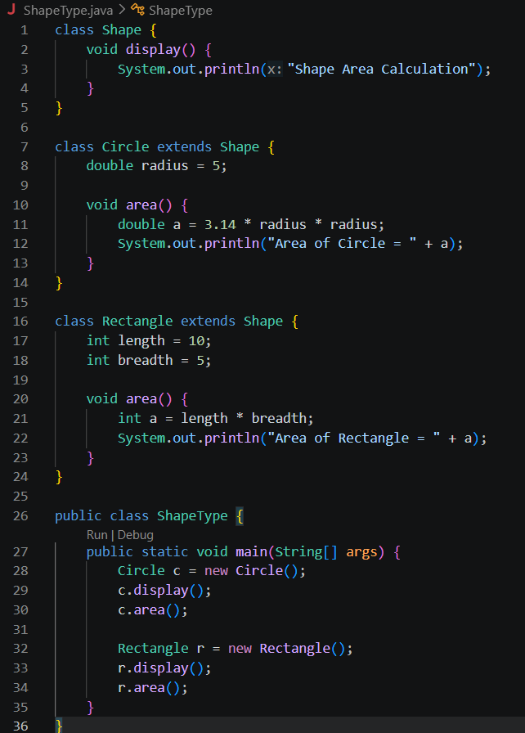
OUTPUT:
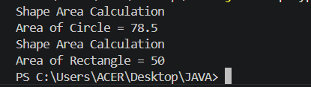

2. Develop a E-Commerce Product System where electronic, clothing, and grocery products inherit common properties and implement product interfaces.
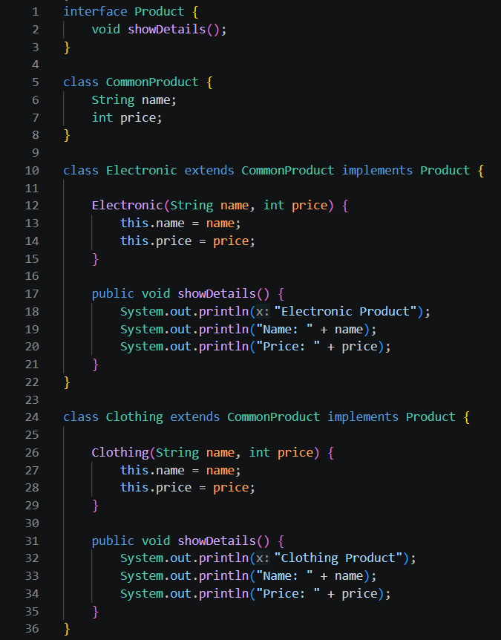
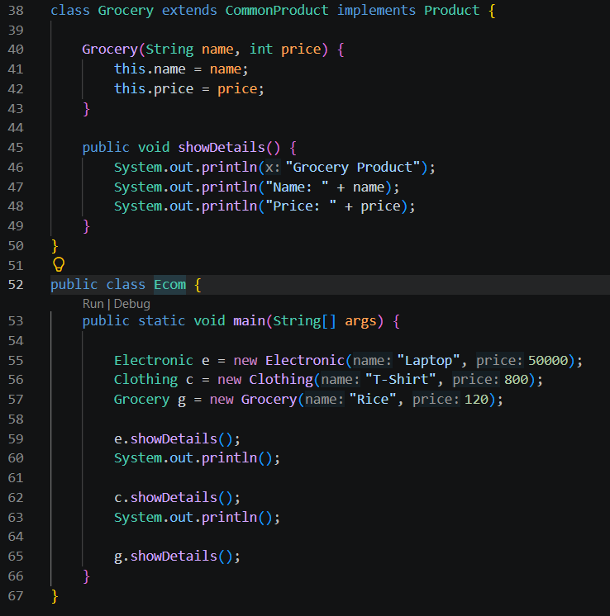
OUTPUT:
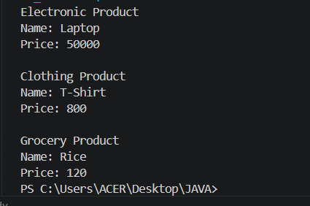
CONCLUSION:
In this experiment, we implemented the concepts of inheritance and interfaces. We learnt the use of keyword extends and implements.

